Problem Solving Worksheet
Step 1  - Define the problem  - What does the data tell us? | List types of data and/or ways of collecting data for staff buy-in:
Step 2  - Define the desired outcome  - What do you want the students to do instead?  - What do you want the staff to do instead? | Write a desired outcome for the problem:  Operationalize- to define so that it can be measured or expressed quantitatively
Step 3  Brainstorm  - What do we do for students?  - How do we support adults?  - How do we maintain the change? | List ideas – no judging/evaluation
Step 4  Prioritize / Evaluate  - Are solutions in alignment with PBS principles? | List those from Step 3 that are in alignment and rank list:
Step 5  Decide on best solution  - Remember the outcome. | List a solution or solutions from Step 4:
Step 6  Determine implementation plan  - Actions/tasks  - Who is responsible  - Timeline
  Action/Task | Who | Timeline
Step 7  Develop an evaluation plan  - How will you know it is working?  - How will information be shared?  Share Plan:
  Tool/Assessment/Data | Measure to reach/obtain

Problem:
There is nothing to hold the staff accountable for follow through with PBS, especially teaching expectations, some staff are not buying in at all.

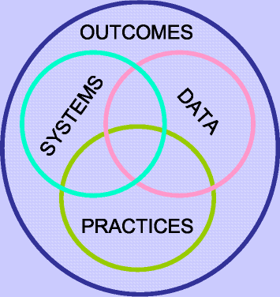
Consider if the problem is related to:
Systems

Practices

Data

Also Consider: Is there a need for Information, understanding Impact, or knowing how to Manage?

